BookKeeper - Group 9

The application is a little bit finicky and requires several things to work right. The best way to get it working in my experience is to just follow the error messages that pop up when you try to run the server. Off the top of my head, I know you need:

* Homebrew/Brew (<https://brew.sh/>)
  + Needed to download the dependencies below, or another package manager which has both of them
* The Yarn Package Manager (downloaded through Homebrew, under package ‘yarn’)
  + Need to run yarn command in the root directory of the project
* Redis-Server (found also through Homebrew, under package ‘redis’)
  + Run before starting the server from the root directory
  + Helps facilitate the database services, can’t add books without it

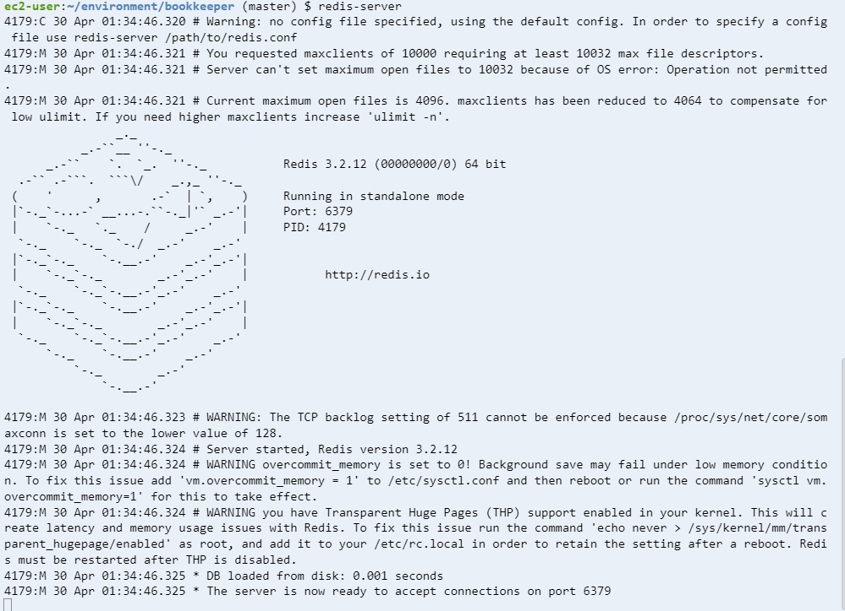

If you run into any problems beyond that, please let me know: cbenne38@uncc.edu